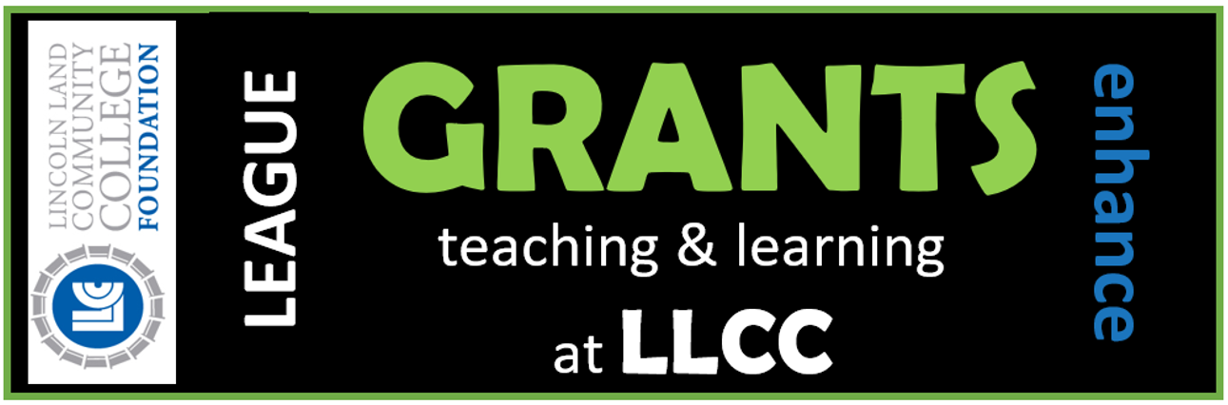

LEAGUE GRANTS

Thank you for your interest in the Lincoln Land
Community College (LLCC) Foundation Grant Program. The mission of the Foundation is cultivating and stewarding charitable gifts to support Lincoln Land Community College students, programs and services/

Each year, the gifts of generous LLCC faculty and staff through the LEAGUE (Leaders Establishing Annual Gifts Underwriting Education) campaign help provide educational excellence at the college. We invite you to submit a proposal for funding for your program.

Grant Awards Guidelines

The Lincoln Land Community College Foundation will be
awarding approximately $10,000 in grant funds in 2019.
The monies available for grants are a direct result of the
success of the annual LEAGUE giving campaign.

- Formal guidelines and applications are available at
www.LLCCFoundation.org or upon request.

- Proposals are reviewed by the LLCC Foundation Grant Review and Allocation Committee.

- Final recommendations are approved by the
Foundation’s Board of Directors.

Deadlines & Award Announcement

An original application is due to the LLCC
Foundation no later than 5 p.m. Thursday,
January 31, 2019. The application deadline will be
strictly followed.

Approved grants will be announced at the
LEAGUE Campaign Kick-off Celebration on
March 26, 2019, from 11:30 a.m. to 1 p.m. in the
Student Union.

Eligibility

There is not a dollar limit set on proposals, however the
highest average amount awarded per grant is generally
$1,500 to $2,000. The Foundation has funded projects
such as:
- Purchasing firefighting gloves for students in the
Emergency Services Program, and

- A 10-inch Saw Stop Contractor saw for LLCC
Jacksonville Building and Trades students.

At this time, the Foundation does not fund travel or
salaries.

Requirements

- Faculty applications must be signed by the submitting
faculty member and the department chair.

- Administrative and staff applications must be signed by the applicant and his/her immediate supervisor.

- Applicants requesting funds for computers and/or
computer hardware/software must have the request
signed by the Chief Information Officer.

- Monies must be spent by June 28, 2019.

- Grant recipients will be required to submit to
the LLCC Foundation Board of Directors in December 2019 a written evaluation detailing the outcomes of the project.

- Applicants whose projects are funded may be asked to
attend a meeting of the LLCC Foundation Board of
Directors to report on their respective projects.

More information is available in the LLCC Foundation,
located on the Springfield campus, level one of Menard
Hall, at LLCC district sites and via the LLCC
Foundation web site at www.LLCCFoundation.org, or
by calling (217) 786-2785.

