STALTER 3-D Design “After Andy Goldsworthy” ART WALK (Down the path from the breeze way in Sangamon South, around the bird feeding area and just across the bridge)
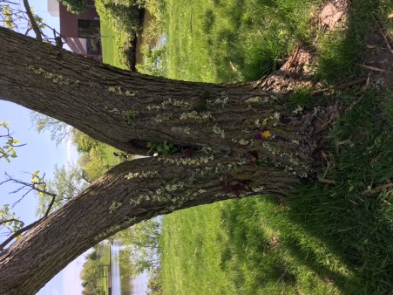 | Sasha Phillips | “Untitled Art #1”  Mud, Clover, Dandelions, & Grass
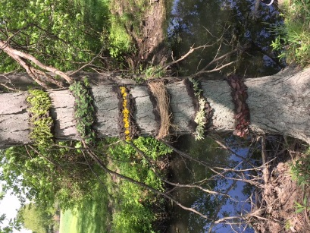 | Drew Silveus | “Marley Stripes”  Mud, Tree Leaves, Dandelions, Clover, and Prairie Grass
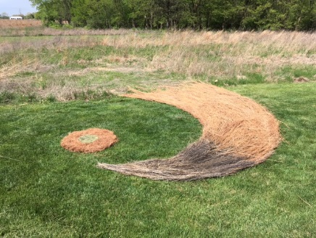 | Professor Stalter | “Great Wave of the Prairie”  Prairie Grass, Pine Needles, Grass Clippings, & Dandelions
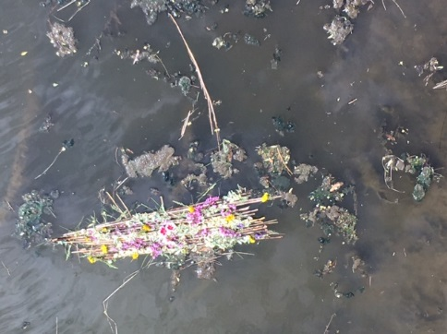 | Aliyah Kinsel, Alicia Windisch, Sydney Jarrard | “Raft of Joy”  Sticks bound with Grass, Wild Flowers
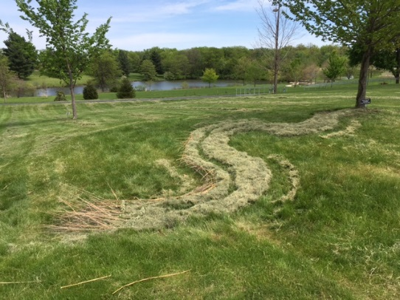 | K. Baer, Jessica Green | “River in Repose”  Mud, Grass Clippings, Prairie Grass, Wild Flowers
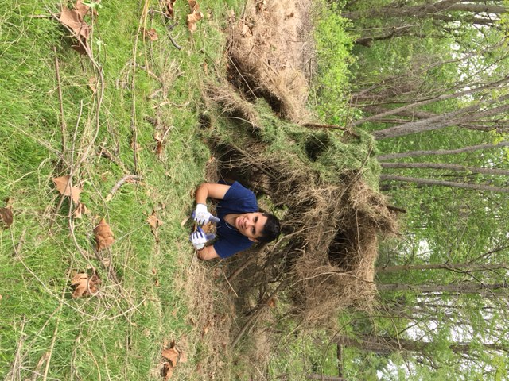 | Miguel Bohrer | “Home Safe”  Sticks, Prairie Grass, & Grass Clippings
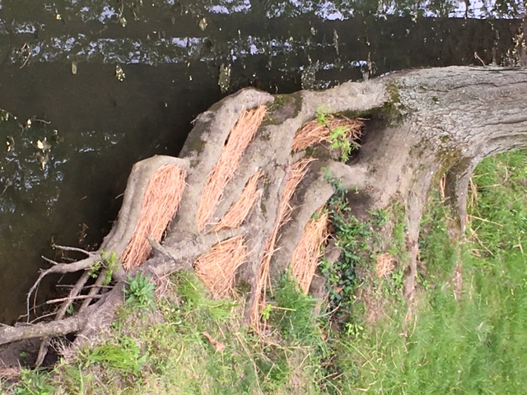 | Ashton Baskett | “Root Flow”  Roots & Prairie Grass
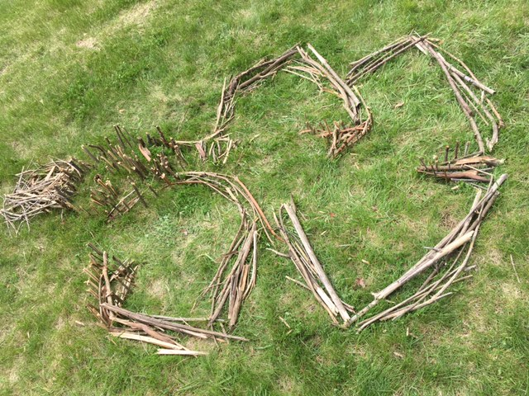 | Kenny Beeler, Lesa-Anne Moss | “Lady with the Pine Cone Eye”  Sticks & Pine Cones
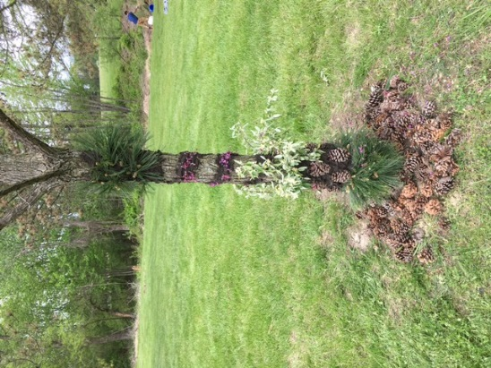 | Anna Walschleger | “All Dressed Up & Nowhere to Go”  Pine Cones, Wild Flowers, Mud, & Pine Needles

