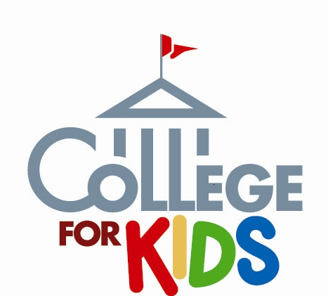
WANTED
Excellent, energetic and creative teachers to participate in
Lincoln Land Community College’s Youth Enrichment Programs!

What is College For Kids?
CFK is our summer enrichment program for students who have completed grades K-2, 3-5 and 6-8 (Springfield) and 3-5, 6-8 (Jacksonville). A variety of classes, one hour in length, will be offered during the months of June (Jacksonville ) and July (Springfield).

Classes will be held Monday through Thursday from 9 a.m. to 12:30 p.m. Students choose three classes to attend throughout the weeklong session, exploring a new interest, discovering exciting challenges, or developing skills in a fun and exciting way!

We want YOU!
We are seeking highly motivated teachers who are interested in teaching topics of personal interest, current trends, and/or subject expertise.

Compensation: $100 per class (1 hour in length, Monday through Thursday). Multiple offerings of the same class are accepted; all classes are contingent upon a minimum enrollment of five students.

If you wish to share your time and teaching talents as part of our CFK faculty, please contact us to request an official “Instructor Proposal Form.”

Proposals are due by December 1, 2014
and are reviewed in the order they are received!
For more information, contact:
Jessica Ingold, LLCC Youth Enrichment Services Coordinator:
Jessica.ingold@llcc.edu 217.786.4905
Thank you for your interest!

