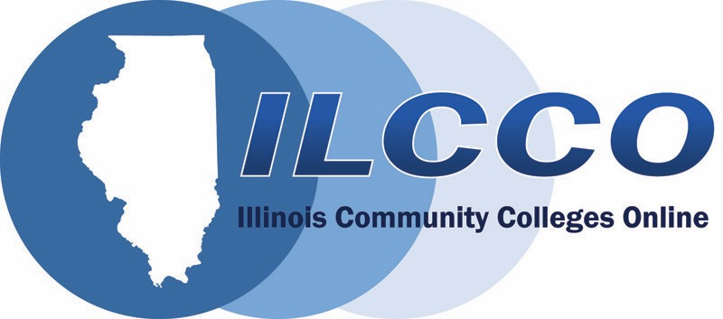

Growing Online Learning
2020: Humanizing the Online Environment: Increasing
Instructor Presence and Enhancing Student Engagement
FREE web-based conference for Illinois community colleges.

February 11 – 13, 2020

KEYNOTE – Humanizing Online Learning
Dr. Michelle Pacansky-Brock
Faculty Mentor for the
California Community Colleges
California Virtual Campus –
Online Education Initiative

February 11  10:00 AM | KEYNOTE: Humanizing Online Learning | Michelle Pacansky-Brock  California Community Colleges  California Virtual Campus
February 11  2:00 PM | Making Instructional Videos Really Work for Instructors & Students | Jenny Pecora & Trisha Dandurand  Kankakee Community College
February 12  10:00 AM | Leveraging your institution LMS to increase Faculty Presence in Online Courses | Selom Assignon  Harold Washington College
February 12  2:00 PM | You've got to Connect! | Kona Jones  Richland Community College
February 13  10:00 AM | Increasing Faculty Presence in an Online Speech Course | Carolyn Stevenson  Harold Washington College
February 13  2:00 PM | The Online Facilitation Instrument – A Helping Hand for the New-to-Online Faculty Member | Jenny Henrikson  Harper College

Registration and additional information are available here.

Sessions

KEYNOTE: Humanizing Online Learning
February 11, 10:00 AM

Dr. Michelle Pacansky-Brock
Faculty Mentor for the California Community Colleges
California Virtual Campus – Online Education Initiative

Humanizing is a pedagogical approach that supports the non-cognitive components of learning and increases the success of more students in online courses. In this presentation, we will consider why supporting the non-cognitive dimensions of learning is so important for students from marginalized groups and look at examples of humanized online teaching strategies. You will see how we are inspiring -- not requiring -- faculty to humanize their online courses through faculty-centric professional development in California.

Making Instructional Videos Really Work for Instructors & Students
February 11, 2:00 PM

Jenny Pecora
Professor English Composition
Kankakee Community College
Trisha Dandurand
Professor English
Kankakee Community College

Over time our approaches to creating and using instructional videos has changed, partly in response to changing technologies and partly in response to specific problems (like spending too much time creating videos or students not even watching them). We’d like to address common issues and discuss how we can make instructional videos really work for instructors and students.

We’ll share research on modern best practices and recommendations for creating and using instructional videos in f2f, hybrid, and online classes; we’ll also share ideas for using programs such as PowerPoint and YouTube, free online screencasting tools (like Screencast-o-Matic), and paid services like VidGrid.

We’ll also open up the conversation to discuss the challenges attendees face when creating and using instructional videos as well as their own best practices. We hope for everyone to walk away with new ideas to try out!

Leveraging your institution LMS to increase Faculty Presence in Online Courses
February 12, 10:00 AM

Dr. Selom Assignon
Instructional Design Manager
Harold Washington College

Instructors play an important role in enhancing interaction and communication among students. This role is even more critical in cyberspace where students do not have the opportunity to get instant feedback like in a face to face environment. This presentation will discuss how online instructors can leverage their institution Learning Management System to increase their online presence and promote active student engagement and participation, which may positively affect retention and success rates in online courses.

You've got to Connect!
February 12, 2:00 PM
Kona Jones
Director, Online Learning
Richland Community College

Teachers who humanize their online course create powerful and impactful learning environments that intrinsically motivate students to do more than the minimum. When students feel like their teacher truly cares about them as a person, as well as their success in the course, it creates a foundation of trust that promotes more meaningful interactions and learning. What does this type of learning environment look like in the online classroom? How does it function? What is the true impact on students and learning outcomes? Connecting with students can be the spark that not only inspires the students but the instructor as well. This presentation will delve into these topics and examples of their impact on students.

Increasing Faculty Presence in an Online Speech Course
February 13, 10:00 AM

Dr. Carolyn Stevenson
Speech Faculty
Harold Washington College

In an online learning environment, students’ interaction and engagement depends in various factors, one of which is instructor’s presence. This presentation will discuss ways online speech instructors can create a strong classroom presence through personalized welcome videos, weekly announcements, online office hours, live sessions and student outreach, which ultimately promote student success in the course.

The Online Facilitation Instrument – A Helping Hand for the New-to-Online Faculty Member
February 13, 2:00 PM

Jenny Henrikson
Instructional & Distance Education Design Specialist
Harper College

We all know that strong course design and consistent facilitation are both imperative for student success in online courses. There are many rubrics and guides available for creating and reviewing the design of courses, but there are fewer quality tools available for guiding faculty members through the course facilitation process. Harper College has found a valuable option that we provide to all new faculty who are teaching online or hybrid courses. Let’s delve into the easy-to-follow Online Facilitation Instrument that is open for use by all!

