Enrolling into a Padlet Backpack Teacher Account at LLCC

- If you will be transferring existing Padlets from Padlet.com, log into your existing Padlet account first using the Chrome or Firefox browser. You may skip this step if you don’t have an existing Padlet account.
- Open a new tab in your web browser and navigate to LLCC’s Padlet Backpack account at this link (llcc.padlet.org).
- Click the the Log in with Microsoft link and enter your LLCC credentials.
- STOP! By default, your account is a student account and you will have to email barry.lamb@llcc.edu to have it changed to a teacher account.
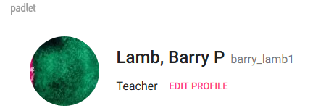
- To verify that your account is a teacher account, click on the account
icon in the upper right corner and choose Profile. You should see the
word teacher under your name (see below).
- You may now log into your LLCC Padlet Backpack account at this link
(llcc.padlet.org) using the Log in with Microsoft option to take advantage
of the features of the LLCC Padlet Backpack Teacher Account.
- While more information about the Padlet Backpack Teacher account will
be coming soon, below are a few highlights:
  - Unlimited Padlets
  - Create folders to organize Padlet walls
  - Bigger file uploads (files up to 250 mb)
  - Integration with Blackboard
  - Easier collaboration with other LLCC users
  - Data and analytics on your Padlets
10/22/19 9:24 pm

Importing Existing Padlets into your LLCC Padlet Teacher Backpack Account

Once your account has been verified as a teacher account, please take the following steps to import existing Padlets from your Padlet.com account.
- If you have an existing Padlet account (from Padlet.com), open a new tab or window and log into this account using the Chrome or Firefox web browser
- Go back to the web browser window where you are logged into your Padlet Backpack account at https://llcc.padlet.org
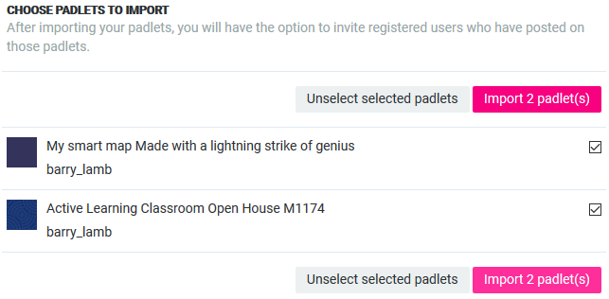
- To import existing Padlets, click on the account icon in the upper right corner and choose Import.
You should see the following screen appear:
- Check the boxes of the Padlets to import or choose Select All Padlets and click the Import button
- Next, either choose collaborators to import or choose Skip to skip this step
- Skip the step entitled Add collaborators to Lincoln Land Community College Backpack
- Click Go to Account Home to see the imported Padlets under the Made link.
10/22/19 9:24 pm

