COMMENCEMENT 2019

TO: Faculty & Administrators
FROM: Lesley Frederick, Vice President, Student Services
DATE: May 14, 2019
SUBJECT: 2019 COMMENCEMENT ACTIVITIES

On Friday, May 17, 2019, the Commencement ceremony will be held at the Bank of Springfield Center,
1 Convention Center Plaza (Eighth Street between Adams and Washington Streets), Springfield, and will begin promptly at 7:30 p.m. with the processional.

Please arrive no later than 7 p.m. so that you can assemble in line. There will be plenty of signs posted directing you to the line-up area so please look for them and follow accordingly. The line of march will be posted in LincIn on May 15th, and will be posted at the line up area.

The seating in The Center will be similar to past years; the graduates will be seated in the center two sections flanked on both sides by rows of intermingled faculty and administrators. A diagram of the processional as well as the line of march, is attached to this memo.

Please note: Due to liability issues, there will NOT be a place to check your personal belongings. A coat rack will be available but will not be supervised. Please leave anything you do not wish to carry in your vehicle.

Processional

FIRST: The Board of Trustees and platform members will proceed into The Center’s main hall; graduating students, faculty and administrators will remain at their designated locations until the platform members are at their seats.

SECOND: When members of the platform party are at their seats, there will be a pause in the music followed by a fanfare, and then faculty and administrators will proceed to their row of seats on each side of the center graduates’ section, led by the two faculty marshals. A program will already be in your chairs—it will not be necessary to pick one up from the ushers.

THIRD: There will be a pause in the music, followed by a fanfare, and the graduating students, led by the marshals, will proceed to their rows of seats.

Recessional

The platform, followed by the faculty and administrators, will move up the inside two aisles and then back to the east end Robe Return area. Again, the two faculty marshals will lead the faculty and administrators out.

PLEASE TAKE NOTE!!
The State Capitol Arts Fair (https://www.springfieldoldcapitolartfair.org)
and the Springfield PrideFest (http://www.springfieldpride.org/entertainment)
will be setting up Friday afternoon for the Arts Fair and PrideFest that will take place on Saturday and Sunday, May 18 and 19.

The City will be closing Washington Street, between 4th and 6th streets at noon on Friday, May 17th and they will close 5th Street, between Jefferson and Adams at 2pm that day.

This should not present a problem with driving or parking, but it is recommended that you leave earlier than you normally would to alleviate any possibility of issues with traffic. The best way to get to the BOSC would be to stay clear of the area around the Old State Capitol by using E. Monroe St. or E. Lawrence Avenue to 9th Street.

PARKING

Parking is available at several locations near the Bank of Springfield Center

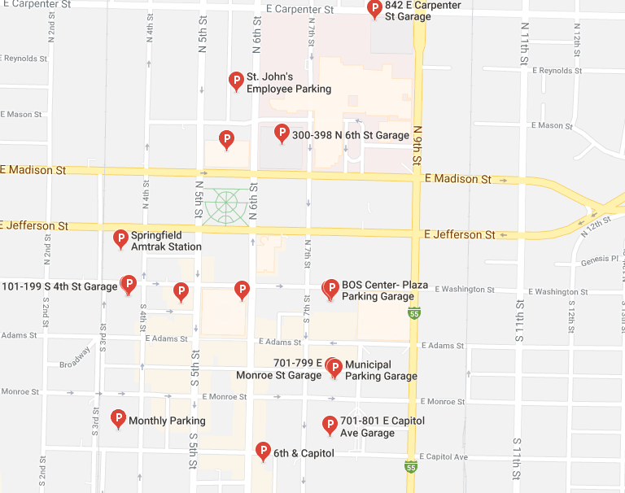

BOS Center – Plaza Parking Garage
767 E Washington St, Springfield, IL 62701
217-788-8800

Plaza Parking Garage
1 Convention Center Plaza
217-788-8800

Municipal Parking Garage
310 E. Washington St.
Springfield, IL 62701
217-789-2038

Underground Parking Garage, Old State Capitol
S. 6th Street, Springfield, Il 62701

701-801 E. Capitol Avenue Garage
701-801 E. Capitol Avenue, Springfield, IL 62757

6th & Capitol
420 S 6th Street, Springfield, IL 62701

Abraham Lincoln Museum Parking
500 E. Madison Street
Springfield, IL 62701

For a complete listing see https://www.downtownspringfield.org/get-around

