Poker Hand Ranking

Royal Flush | 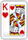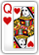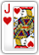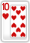 | A straight from a ten to an ace with all five cards of the same suit. In poker all suits are ranked equally.
Straight Flush | 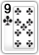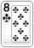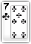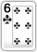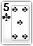 | Any straight with all five cards of the same suit.
Four of a Kind | 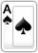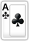 | Any four cards of the same rank. If two players share the same Four of a Kind, the bigger fifth card (known as the kicker) decides who wins the pot.
Full House | 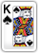 | Any three cards of the same rank together with any two cards of the same rank. Our example shows "Aces full of Kings" and it is a bigger full house than "Kings full of Aces."
Flush | 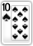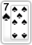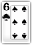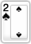 | Any five cards of the same suit (not consecutive). The highest card of the five determines the rank of the flush. Our example shows an Ace-high flush, which is the highest possible.
Straight | 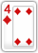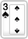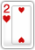 | Any five consecutive cards of different suits. Aces can count as either a high or a low card. Our example shows a five-high straight, which is the lowest possible straight.
Three of a Kind | 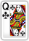 | Any three cards of the same rank. Our example shows three-of-a-kind Aces, with a King and a Queen as side cards - the best possible three of a kind.
Two Pair | 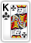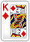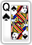 | Any two cards of the same rank together with another two cards of the same rank. Our example shows the best possible two-pair, Aces and Kings. The highest pair of the two determines the rank of the two-pair.
One Pair | 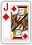 | Any two cards of the same rank. Our example shows the best possible one-pair hand.
High Card | 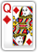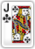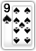 | Any hand not in the above-mentioned hands. Our example shows the best possible high-card hand.

