Upgraded PeopleAdmin Landing Page FAQs & Screenshots

What is Hire?
- Hire is the new name of the applicant tracking solution we have through PeopleAdmin.

What is the benefit of this new landing page?
- The upgraded landing page will incorporate an easy to use inbox from which you can access your action items without having to change your user group (i.e., changing from Hiring Manager to Budget Manager).
- You will be able to filter and sort the inbox for even easier access to what matters most.

What all can I see and access from this new inbox?
- You will be able to see all of your action items, including those assigned to you as a search committee member.
- You will also notice a few added fields to help you better find and prioritize your work, including the department and days in current workflow state.
- You will be able to access and take action on any action item without having to manually change your user group.

What are the different widgets on the home page?
- There are a handful of simple data visualizations (or “widgets”) on the new home page.
- These will answer questions like, “How many postings were filled in the last 30 days?” for HR or “How long are things sitting in my inbox on average?” for an approver. These “widgets” are persona-based with different visualizations for HR, reviewers and approvers.

Overall Picture of New Landing Page
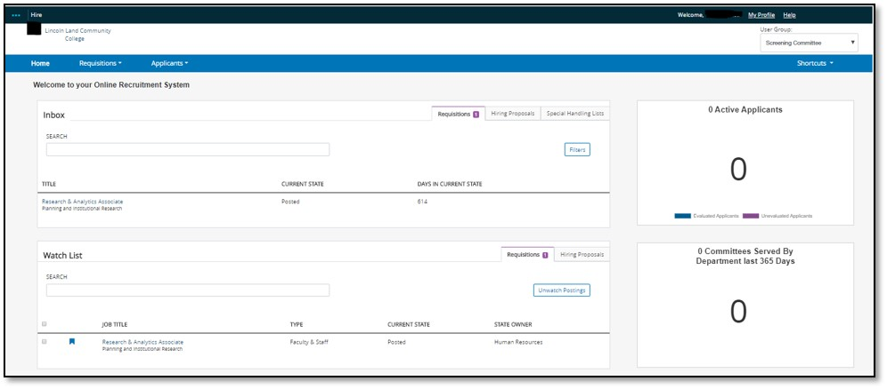

Features
Click to quickly access the Requisitions and Hiring Proposals that need your attention. Bonus is that you don’t have to switch your User Group any longer. The system will switch for you depending on the action you are taking.
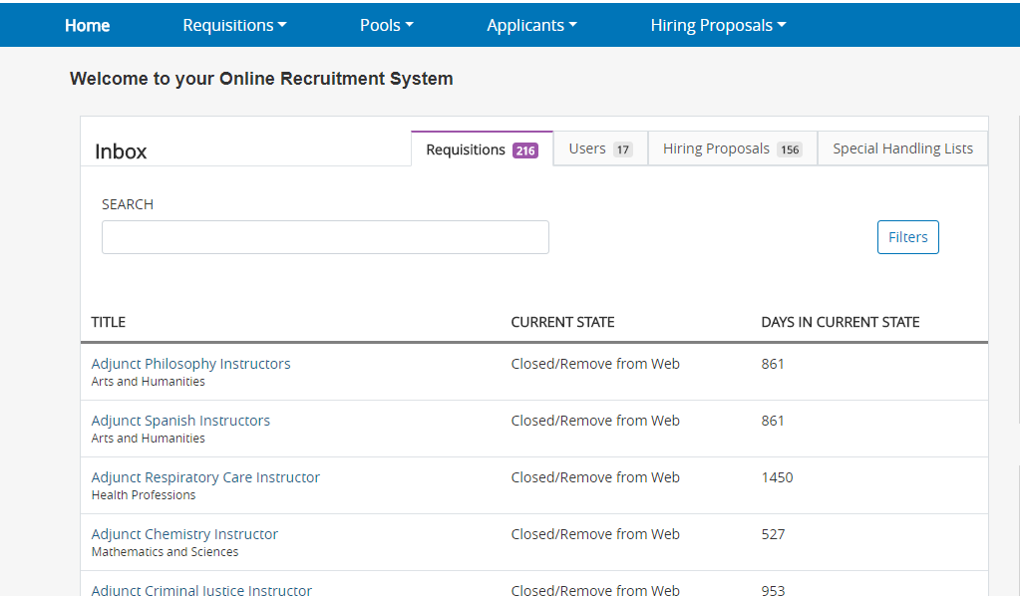
You can easily search and filter to narrow your results.

Watch List
Requisitions and Hiring Proposals you’ve added to your Watch List can be easily accessed from landing page.
