Cherokee Purple
Excellent flavor
Great for slicing
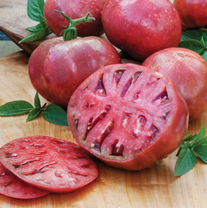

Nebraska Wedding
Excellent flavor
Good yields
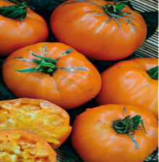

San Marzano
Great for sauces and canning
Sweet and complex flavor
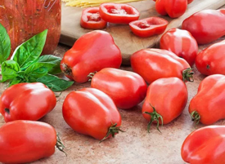

Solar Flare
High producer
Very durable
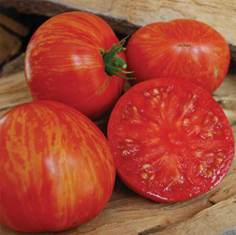

Black Cherry
Dynamic and wonderful flavor
Excellent for salads and shish kabobs
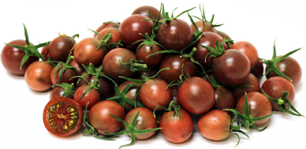

Brandywine
Very large fruits
Perfect for pastes
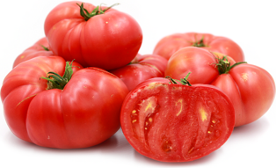

German Pink
Great for canning and slicing
High yield
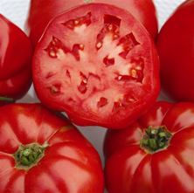

Hillbilly Potato Leaf
Rich and sweet flavor
Brilliant and beautiful coloring
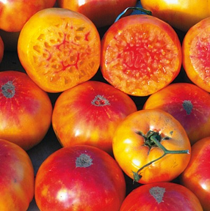

Dad’s Sunset
Great and zesty flavor
Beautiful and flawless fruits
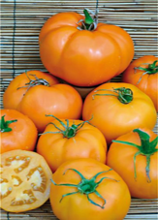

Indigo Apple
Remarkable color varieties
Durable and delicious
