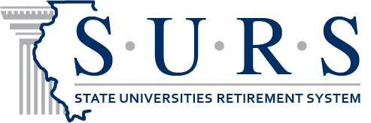 News Release
Oct. 2, 2017

FOR IMMEDIATE RELEASE
CONTACT: Beth Spencer, Communications Manager - 217.378.7512

SURS 2018 Board of Trustees Election
Martin Noven, board secretary and executive director of the State Universities Retirement System (SURS), has announced the System will hold a board election during April 2018 to fill three expiring trustee positions. An impartial election services company will conduct the election. Candidate packets and petition forms are available from SURS. Candidates should contact Kelly Carson at kcarson@surs.org for information. Completed petitions will be due to SURS on Jan. 31, 2018.

The SURS Board of Trustees consists of 11 trustees: five appointed by the governor including the chairperson who also serves as the chair of the Illinois Board of Higher Education, four active members elected by SURS active members, and two annuitants elected by the annuitants of the System.

Two active board member terms and one annuitant (retired) board member term will expire in June 2018. Dorinda Miller, Steven Rock and John Engstrom currently hold the seats, respectively.

The voting period will be April 2 through May 1, 2018, with results to be announced on May 4, 2018. Active member candidates are nominated by petitions in writing, signed by no less than 400 participants. Annuitant candidates are also nominated by petitions in writing, signed by no less than 100 annuitants. All candidates must also complete an application.

All eligible SURS members will receive a ballot along with candidate information prior to April 2, 2018. Members will be able to vote by returning a paper ballot in a postage-paid envelope, by phone or online. Voting will be handled directly through the election services company.

The SURS Board of Trustees meets quarterly, with additional committee meetings scheduled throughout the year. Trustees are also required to meet certain annual ethics, legislative and fiduciary training as well as complete eight hours of educational conferences on investments and public pension administration.

Elected trustees serve six-year terms.

All SURS members are encouraged to consider running for a trustee position.

SURS Election Process Dates:
Oct. 2, 2017 | Candidate packets and petition forms available  Contact: kcarson@surs.org
Oct. 2, 2017 – Jan. 31, 2018 | Petition circulation period
Dec. 30, 2017 | Candidate applications due
Jan. 31, 2018 | Petitions due
Feb. 5-9, 2018 | Petitions validated
March 21, 2018 | Election materials mailed to members
April 2 - May 1, 2018 | Voting period
May 1, 2018 | Election Day – All ballots due
May 4, 2018 | Election results announced
July 15, 2018 | Trustee terms begin

SURS, 1901 Fox Drive, Champaign, IL 61820

