LLCC Library’s Edible Book Festival- Tuesday, April 14
What is it? The purpose of this event is to have fun & flex our creative muscles while celebrating all things literary—via food—in honor of National Library Week. On this day we merge the fun of reading & eating together to create food that resembles a book; inspired by a scene or character (perhaps the sorting hat from Harry Potter); rooted in a literary theme; or even a play on words (think Scarlet Cheddar instead of Scarlet Letter).
Who can participate? Everyone. Students, staff, faculty, ESAs, etc. All skill-levels are needed. If you are a great home baker & cook, then we want you. If you are not a good cook, then we want you as well. This day is meant to be about fun and creativity & is not about skill level. Bring your “books” to the library on the morning of Tuesday, April 14.
Individuals & groups are highly encouraged. If you don’t want to do it on your own, then grab a co-worker or 2—perhaps an area/department wants to make one—or get friends & family involved.
What are the rules? There is only one rule: when you make your “book” everything should be edible (i.e. don’t use super glue to hold your “book” together).
What kind of food do I use to make my edible “book”? You can use any type of food whether homemade or store-bought. In the past, “book” mediums included: cake, cookies, pie, bread, fruit, cheese, soup, rice krispie treats, twinkies, sandwich fixings, sushi... You are only limited to your own imagination and creativity.
Will there be prizes? Of course! Two prizes will be awarded to the two crowd favorites.
Ok, I’m interested, but still have questions. No problem. If you have questions, then contact Leslie Rios, leslie.rios@llcc.edu or 786-4617.
Need inspiration? Check out LLCC’s Edible Book Festival Pinterest Page:
https://www.pinterest.com/bookish2/llcc-edible-book-festival/

Please support this event & help make it a success by creating an “Edible Book”!
Schedule of the Day's Events:
7:30am-10:45am: Drop off Edible Book @ LLCC Library
11am-noon: Viewing of "books" & Voting for favorites
Noon-??: Announce winners & eat the “edible books”
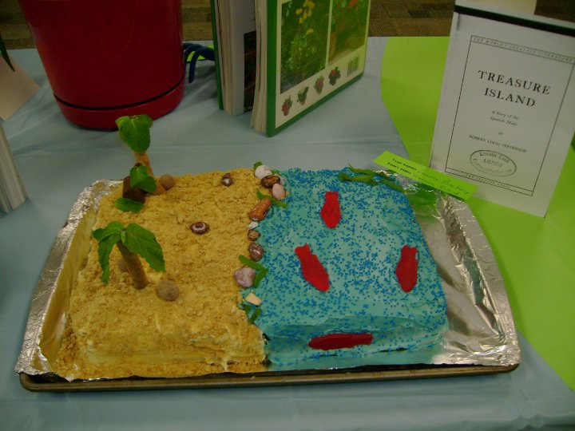
Devil Wears Prada (cookie)
Treasure Island (cake)
Rabbit at Rest (rice krispies)
Tortilla Flat (tortilla roll-up)

