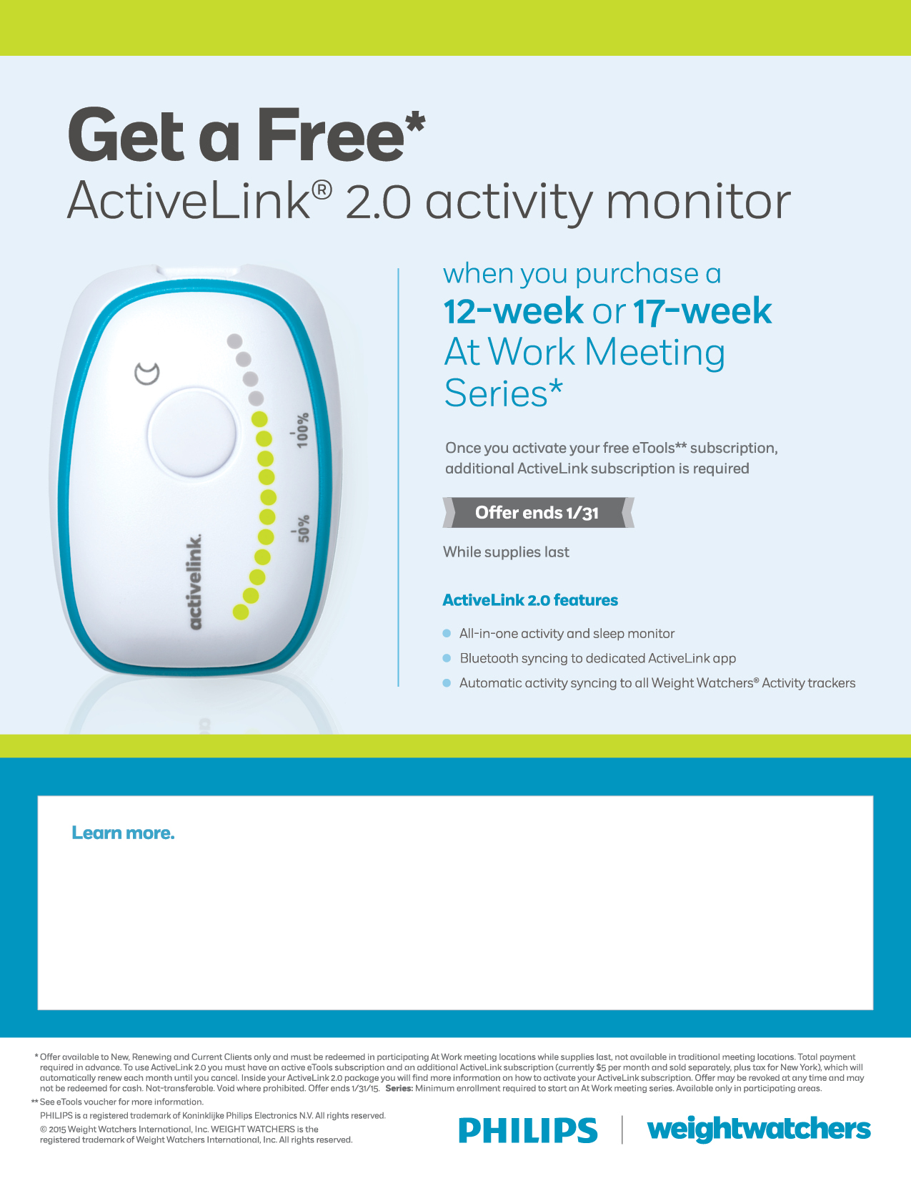

**COME ATTEND OUR INFORMATION SESSION AND JOIN WEIGHT WATCHERS!**

Contact: Kim Elder, Human Resources

Information: [kim.elder@llcc.edu](mailto:kim.elder@llcc.edu) or ext: 62214

*WHILE SUPPLIES LAST

*LEADERS MAY NOT HAVE ON HAND, BUT WILL DO ALL THEY CAN TO GET ONE FOR THE FOLLOWING WEEK.