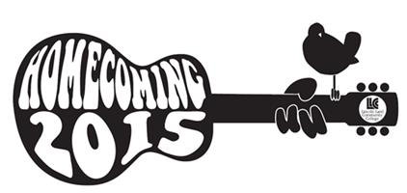

Lincoln Land Homecoming Court
Nomination Form
Saturday, February 14th 2015
Homecoming Basketball Games: WBB 2pm, MBB 4pm, Cass Gym
Homecoming Dance 8pm, Student Union

Nominee must:
- Be nominated by a student or faculty/staff member based on leadership, achievement, service to the community, etc.
- Be a current student at LLCC enrolled in at least 6 credit hours for spring semester
- Have a 2.0 or higher cumulative GPA

Nominee name (print):____________________________________
Nominator name (print): ___________________________________
Nominator Signature:_______________________________________
Date: __________________________
(Complete reverse side)
Please indicate why you are nominating this person for Homecoming Court (leadership skills, academic achievements, community service, employment, etc.).
Please be as specific as possible, nominations will be reviewed by college staff members in order to select Court members.
____________________________________________________________________________________________________________________________________________________________________________________________________________________________________________________________________________________________________________________________________________________________________________________________________________________________________________________________________________________________________________________________________________________________________________________________________________________________________________________________________________________________________________________________________________________________________________________________________________________________________________________________________________________________________________________________________________________________________________________________________________________________
Return nomination form to the Student Life Office located in the lower level of Menard Hall by 5 p.m. on Monday, January 26th.

