Submissions are now being accepted for
The Lincoln Land Review
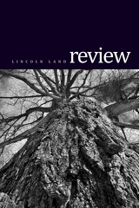
LLCC’s Student Journal of
Writing and Art
Please send original work in the categories of poetry, short fiction, academic non-fiction, fiction, digital media and fine art to: LincolnLandReview@llcc.edu
Entries may be on any topic, subject, or theme. Multiple entries are welcome.
Submissions will automatically be entered into the 2014-2015 LLCC Writing and Art Contest for a $50 cash prize in each category.
Deadline: December 10th, 2014
For further submission requirements, please visit lincolnlandreview.org

