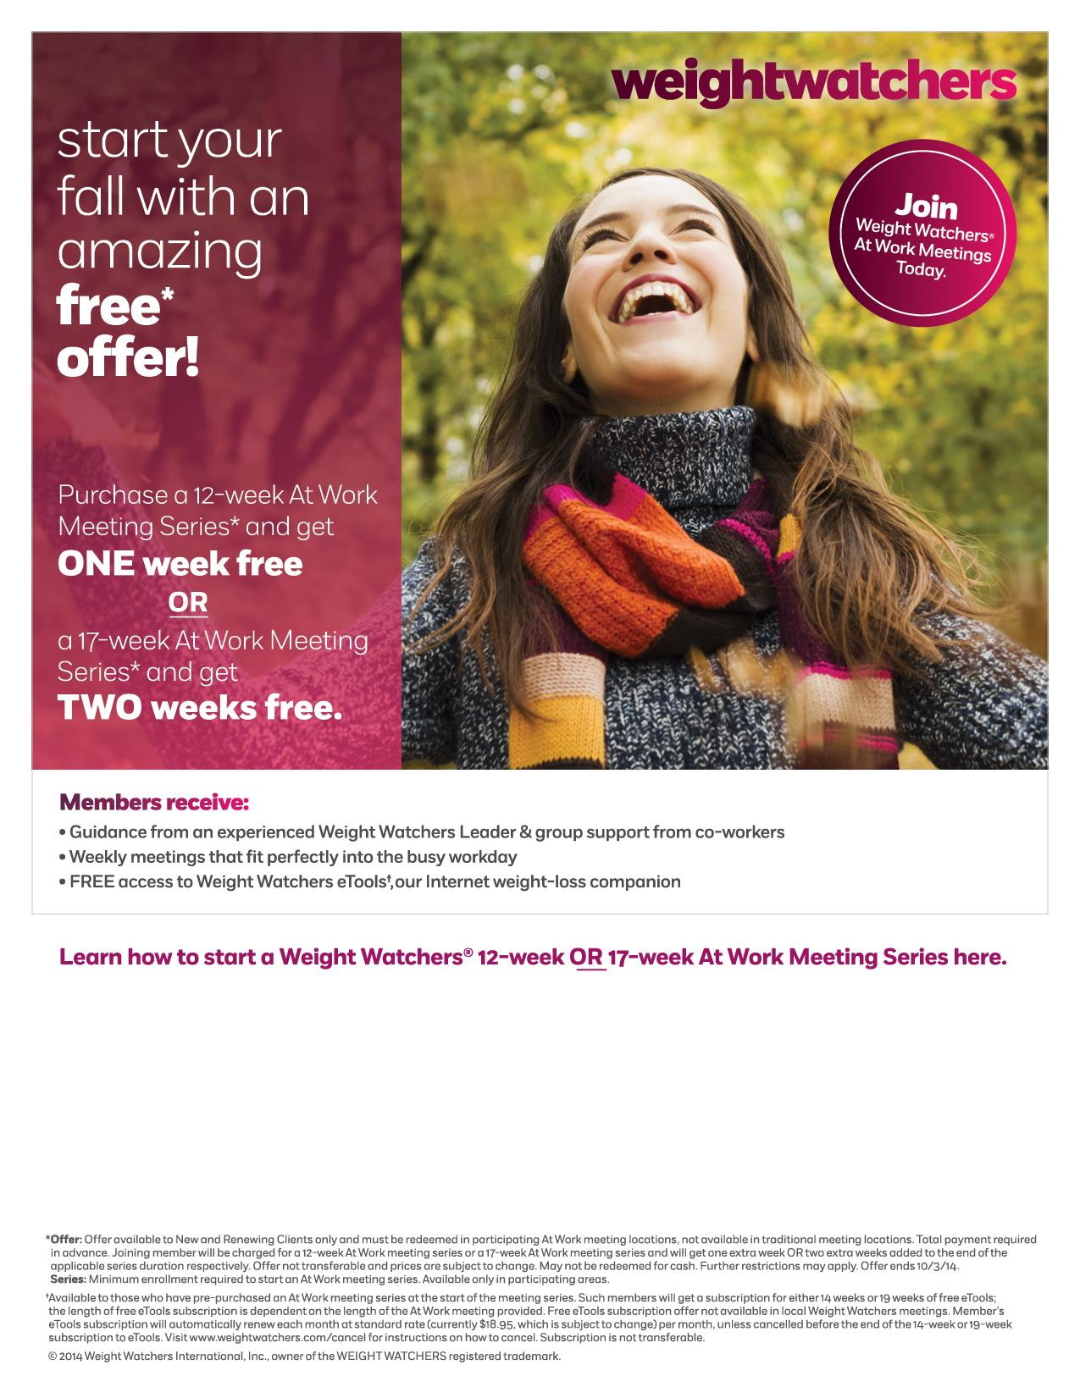

Weight Watchers can bring a meeting on site with enough interest!

Meetings! FREE eTools! Simple Start Program!

For more information, contact: